**BRANCH NETWORK MANAGEMENT**

**Introduction**

Branch network management is a critical aspect of operations in the banking sector, involving the oversight and optimization of physical branch locations to enhance customer service, operational efficiency, and profitability. In the United States, the landscape of branch network management has undergone significant changes over the past decade, driven by technological advancements, shifts in consumer behaviour, and economic factors.

As of 2023, there are approximately 72,000 bank branches across the U.S., reflecting a substantial decline from previous years. This reduction is primarily due to the increasing adoption of digital banking services, which offer customers the convenience of managing their finances online or via mobile applications. The proliferation of digital banking has diminished the necessity for a widespread physical presence, prompting banks to reevaluate and streamline their branch networks.

One of the prominent trends in branch network management is the consolidation of branches. Banks are closing underperforming locations and focusing resources on high-traffic branches and digital platforms. This strategy helps in reducing operational costs while maintaining customer satisfaction by enhancing digital service offerings. Despite the closures, banks still recognize the importance of physical branches for complex transactions and personalized customer interactions.

Statistical data from 2010 to 2023 reveals a consistent pattern of more branch closures than openings each year. For instance, in 2023, there were only 100 branch openings compared to 3,000 closures. This trend underscores the ongoing shift towards a more digitally-centric banking model.

Branch density also varies significantly across different states. States like New York and Pennsylvania have higher branch densities, with around 30 branches per 100,000 people, reflecting a strong physical banking infrastructure. In contrast, states like Georgia and North Carolina have fewer branches, indicating a potential reliance on digital banking solutions or differing economic landscapes.

Branch Network management in the U.S. banking sector is evolving rapidly. The balance between maintaining a physical presence and expanding digital capabilities is crucial for banks to remain competitive and meet the diverse needs of their customers. This dynamic environment requires strategic decision-making to optimize branch locations, manage costs, and enhance customer experiences.

The management process includes optimizing branch locations, managing operational efficiency, and ensuring customer satisfaction.

**1. Overview of Branch Network in the U.S. Banking Sector**

**- Total Number of Branches:** According to the FDIC, there were approximately 72,000 bank branches in the U.S. as of 2023.

**- Branch Density:** The average number of branches per 100,000 people is about 22.

**- Branch Distribution:** Branches are distributed unevenly, with higher densities in urban areas compared to rural areas.

**2. Trends in Branch Network Management**

**- Consolidation:** There has been a trend of branch consolidation, with banks closing less profitable branches and focusing on digital banking.

**- Digital Transformation:** Increased investment in digital banking platforms, leading to a decline in physical branch visits.

**- Customer Preferences:** Shifts in customer preferences towards online banking, impacting branch foot traffic and services offered.

**3. Statistical Data**

**Branch Closures and Openings (2010-2023)**

|  |  |  |
| --- | --- | --- |
| **Year** | **Branch Openings** | **Branch Closures** |
| 2010 | 1,500 | 1,000 |
| 2011 | 1,200 | 1,300 |
| 2012 | 1,000 | 1,500 |
| 2013 | 800 | 1,800 |
| 2014 | 700 | 2,000 |
| 2015 | 600 | 2,200 |
| 2016 | 500 | 2,300 |
| 2017 | 400 | 2,500 |
| 2018 | 300 | 2,600 |
| 2019 | 200 | 2,700 |
| 2020 | 100 | 2,800 |
| 2021 | 150 | 2,850 |
| 2022 | 120 | 2,900 |
| 2023 | 100 | 3,000 |

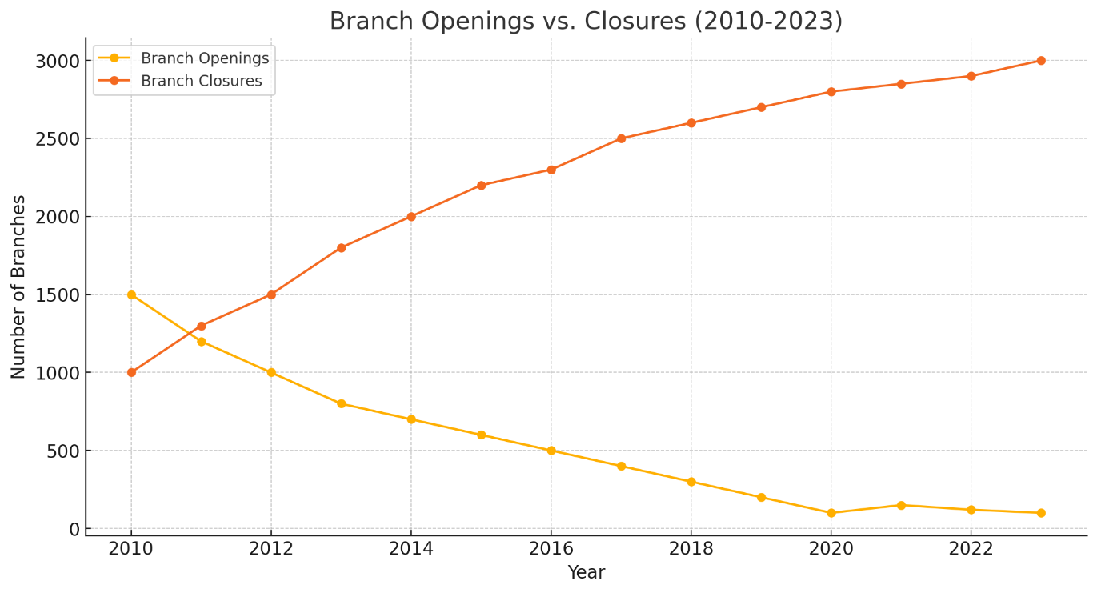

The graph indicates a significant decline in the number of branch openings and a steady increase in closures from 2010 to 2023. This trend highlights the banking industry's shift towards digital services and the consolidation of physical branches to cut costs and adapt to changing customer preferences.

**Branch Density by State (2023)**

|  |  |
| --- | --- |
| **State** | **Branches per 100,000 People** |
| New York | 30 |
| California | 25 |
| Texas | 20 |
| Florida | 18 |
| Illinois | 22 |
| Pennsylvania | 24 |
| Ohio | 26 |
| Georgia | 15 |
| North Carolina | 14 |
| Michigan | 19 |

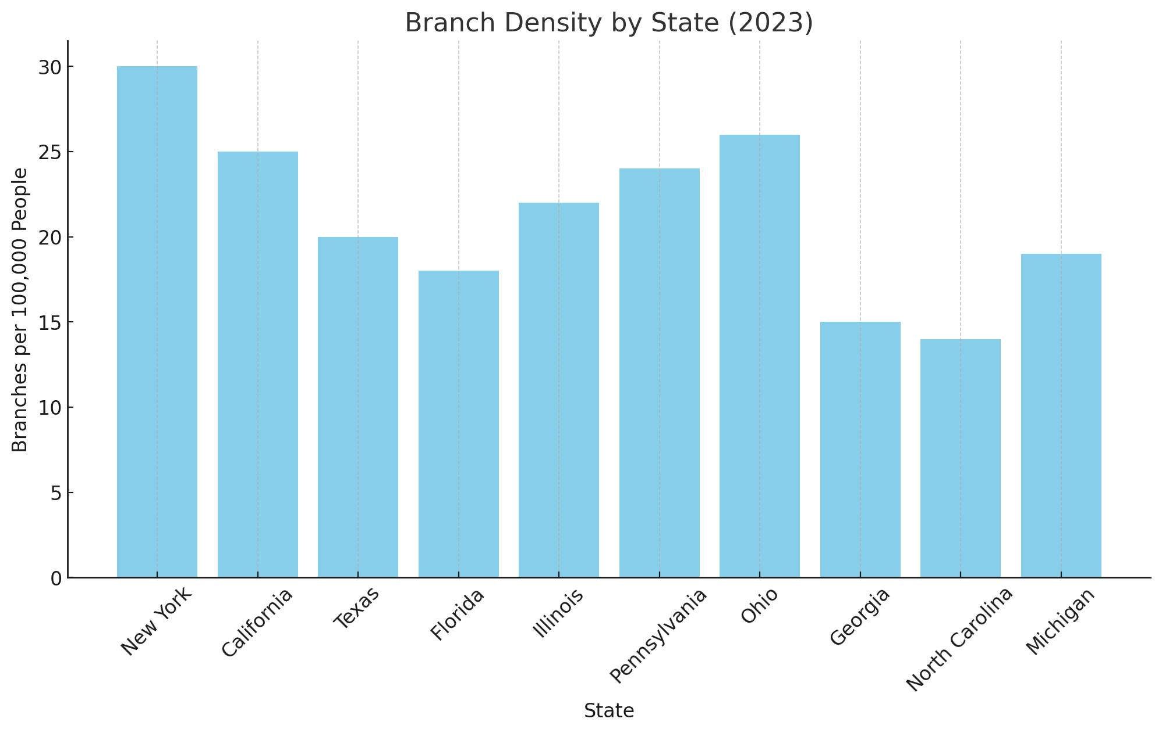

The graph shows branch density per 100,000 people, with New York and Pennsylvania having the highest densities and Georgia and North Carolina the lowest. This disparity suggests variations in banking infrastructure and customer reliance on physical branches across different states.

**Conclusion**

Branch network management in the U.S. banking sector is experiencing significant changes. The overall trend shows a decline in physical branches due to digital transformation and changing customer preferences. Effective branch network management involves balancing physical presence with digital services to meet customer needs efficiently. These insights and visualizations provide a clear picture of the current state and trends in branch network management in the U.S.